**ONLINE INTERACTION SYSTEM**

**OBJECTIVE:**

In this application, we are implementing an application for the purpose of communication between the students, faculties and admin with the help of python technology.

**ABSTRACT:**

Online interaction continues to expand at educational institutions around the globe. Educators must better understand how interaction with online content impacts student engagement and learning. Advances in technology amplify the imperative to gain further insights into how delivery of course materials can enhance and support the learning process. This application investigates student patterns of access to instructional resources provided in an asynchronous online digital literacy. In this we are implementing an application for students, faculties and admins to easily communicate each other. These studies mainly focus on private chat with students and faculties based on their requirement. And admin can post the questions and he collects the information from the students and faculties votes and based on their vote’s admin take the action for the organization.

**KEYWORDS**: Online Interaction, Private, Communication System.

**EXISTING METHOD:**

The current system for interaction between the students, faculties and admins in education system are using the manual process only. It is difficult to communicate in such a case of huge number of students. This difficulty can overcome by using proposed system technology.

**DISADVANTAGES:**

* Difficult to communicate many students.
* Private communication is not possible.
* Difficult to collects the information from students and faculties.
* It takes more time.

**PROPOSED METHOD:**

In the proposed system by using latest python technology, we build an application for easy communication and it also helpful to communicate in private manner who have authorized from admin.

**PROJECT FLOW**:

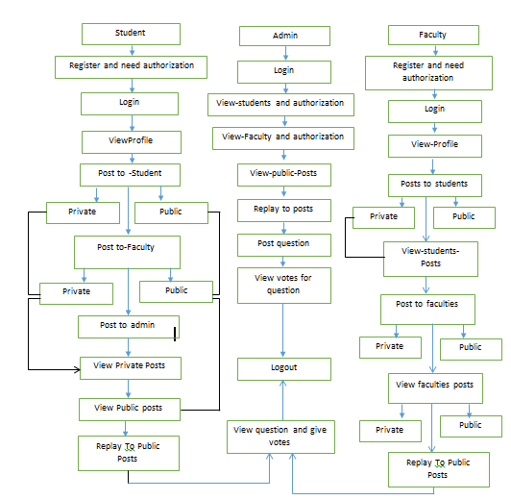

**ADVANTAGES:**

1. It takes less time to communicate.
2. Users friendly.
3. Communication between the students and faculties is also done by private manner also.

**HARDWARE & SOFTWARE REQUIREMENTS**

# **H/W CONFIGURATION:**

# Processor - I3/Intel Processor

* Hard Disk -160GB
* Key Board - Standard Windows Keyboard
* Mouse - Two or Three Button Mouse
* Monitor - SVGA
* RAM - 4Gb

**S/W CONFIGURATION:**

* Operating System : Windows 7/8/10
* Server side Script : Python, HTML, MYSQL, CSS, Bootstrap
* IDE : PyCharm
* Libraries Used : PANDAS, Flask, Smtlib
* Technology : Python 3.6+